CABLE TYPES

# CONTENTS

* Cable Types
* Exterior of a PC
* USB Connector Types
* USB Cables
* Video Cables
* Storage Cables

# CABLE TYPES

* computers measures data transfer and storage using bits and bytes respectively
* bits – b , bytes – B
* data transfer rate bps
  + if it takes 2 seconds to send 50b worth of data, the transfer rate is 25bps. So it is just the division of the amount of data by the time taken to transfer
* K(capital) – kilo
* there are 8 bits per byte
* know the different domains and what they stand for
* make notes of key facts not present in the study guide, and then note examples, images, illustrations to better understand when revising the study guides

# EXTERIOR OF PC

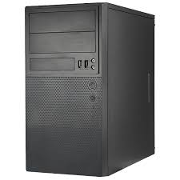

fig 1. tower style computer

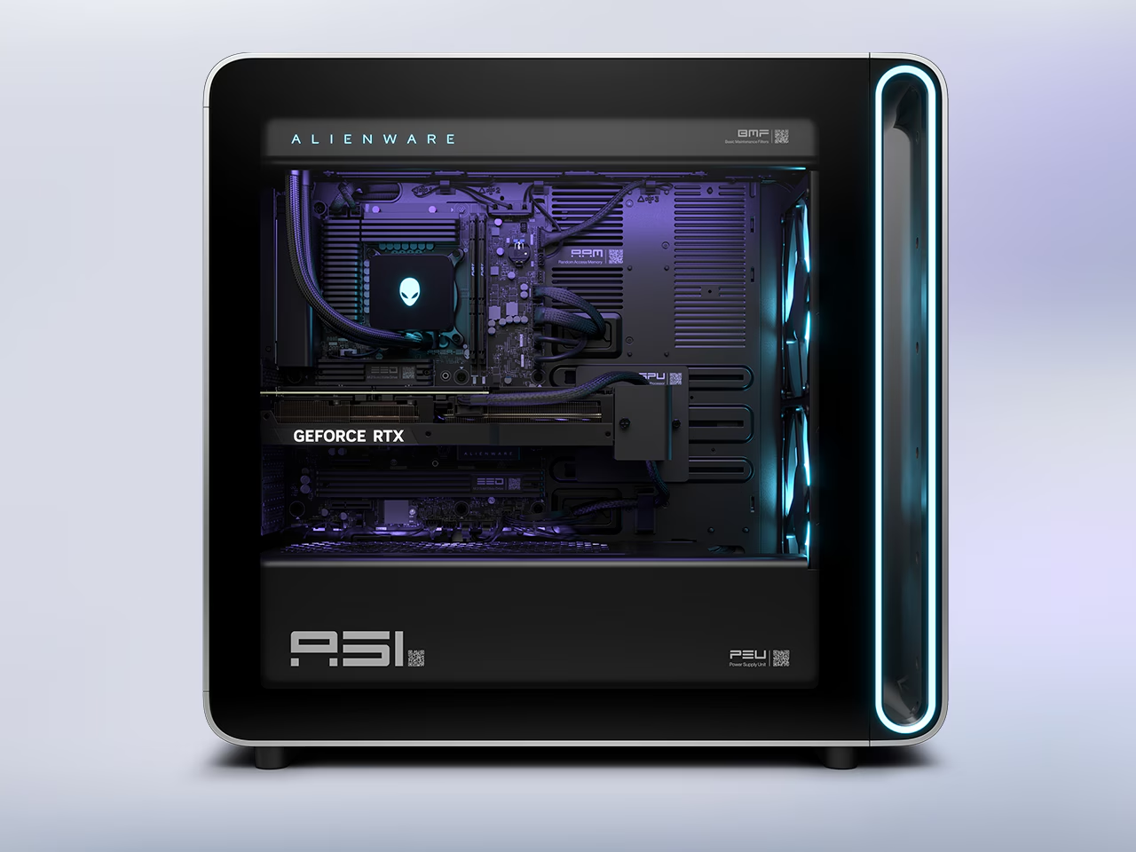

fig 2. gaming style computer

* Expansion cards (also called add-on cards or expansion boards) are hardware components that you can install into a desktop computer's expansion slots on the motherboard to add or enhance functionality, They allow you to customize, upgrade, or extend a computer’s capabilities beyond what the motherboard offers.
* Unknown connectors:
  + SPDIF Connector
  + Expansion slots

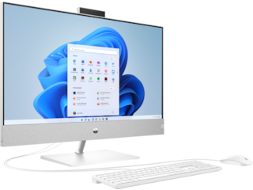

fig 3: All in one computers

* mac mini is a really small tower
* revise sections you might need as reference materials when the need arises(watch the videos, while using the study guides and your note for the exact session you need to reference)

# USB CONNECTOR TYPES

Ultimate connector reference: <https://www.dropbox.com/scl/fi/qfrgyfnirhj7lyv1t5g76/Ultimate-Connectors.jpg?rlkey=2lqz8yn5higqbb25671ih8y5j&e=2&dl=0>

* DB9 and DE9 refer to the same connector, but DB9 is the technically inaccurate and casual name of DE9
  + Reason for Confusion:

"D-sub" connectors come in different shell sizes, designated by a letter:

* + - DA: 15 pins (e.g. VGA)
    - DB: 25 pins
    - DC: 37 pins
    - DD: 50 pins
    - DE: 9 pins
  + The "DB" prefix originally referred to the 25-pin version (DB25). Over time, people started using “DB” for other sizes too, including 9-pin connectors.
  + So, while "DB9" is common in industry and manuals, it's a misnomer. The correct name for a 9-pin serial connector is DE9, because it has an E-size shell with 9 pins.
* A type A connector is the most commonly used connector on laptops and desktops

# USB CABLES

* Daisy chaining is a term used in both electronics and computing to describe a method of connecting multiple devices in sequence or in a linear series. You can use daisy chaining to connect up to 127 devices to a single port on a device using a usb hub
  + 127 devices is a theoretical limit tho, practically it should be lesser
* Ports are controlled by a **Host Controller,** and each host controller uses the same amount of bandwidth for all devices on a particular port 2:49, so if you have a single device connected to a usb type 3 port, the transfer rate would be up to 5 gigabits per second, but if you daisy chain 5 devices you now have up to 1 gigabit per second per device, devices in a particular chain share bandwidth
* for people using recent usb they shouldn’ t need to consider daisy chaining an issue as they are really fast, but for older usb this is quite a significant reduction in speed
* 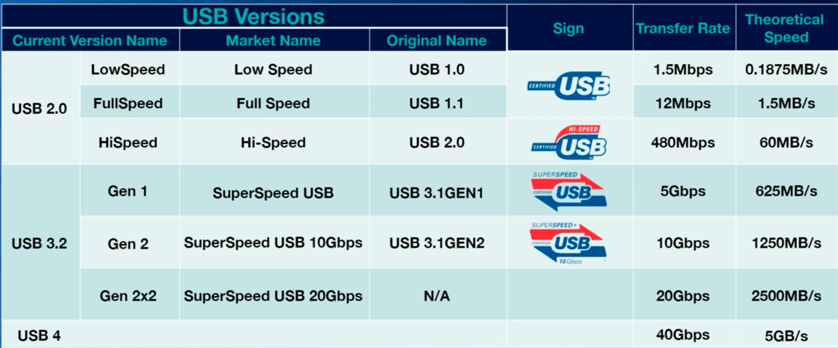
* the faster the speed you need, other limitations come into play: As the longer the cable is, the more the resistance that builds up in that cable and the more the speed and the signal is going to deteriorate
* the distance limations per usb versions:
* sometimes manufacturers exceed the maximum specifications that should be supported by a device, for a example a 20 feet long cable, which would lead to signal detorioration which would lead to slower cables and smaller transfer rates
* usb cables can also power devices, and just like with data transfer speeds the amount of power you can provide for a device based on the generation of USB that you’re gonna be using
* 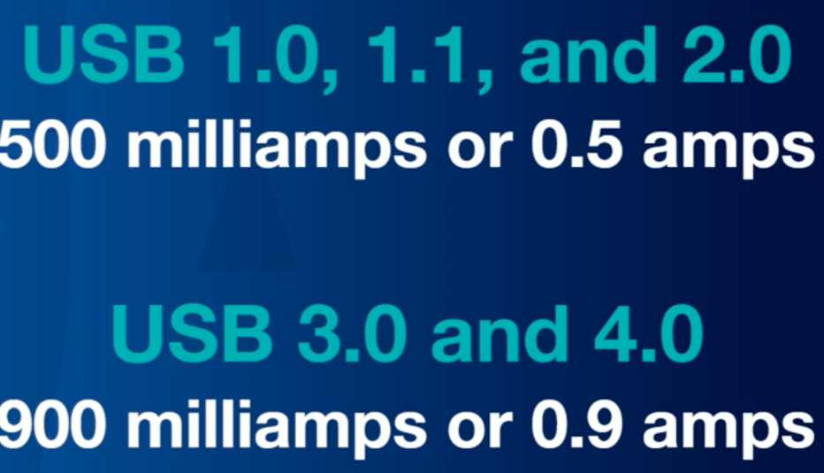
* dedicated powered device (pd) ports offer more power than regular ports: so it’s more like how your device would charge faster to a wall outlet than to your laptop, the speed of charging would depend on whether it’s a pd port and the version of it

# VIDEO CABLES